HR ATTRITION USING RANDOM FOREST CLASSIFIER WITH PYTHON
Every year, several businesses hire a large number of people. Companies devote time and money to educating new personnel, and there are also training programs within the companies for their current staff. The goal of these initiatives is to enhance the effectiveness of their personnel. But how does HR Analytics fit into all of this? Is it only about boosting employee performance?
- HR Analytics
Human resource analytics (HR analytics) is a subfield of analytics that refers to applying analytic methods to an organization's human resource department in the hopes of enhancing employee performance and thereby obtaining a higher return on investment. HR analytics is more than just collecting data on employee productivity. Instead, it seeks to give insight into each process by collecting data and then analyzing it to make pertinent judgments on how to enhance these operations.
- Attrition in HR
Human resource attrition refers to the steady loss of personnel over time. In general, somewhat high attrition is an issue for businesses. HR experts frequently take the lead in developing business remuneration plans, work cultures, and motivating systems that aid in the retention of outstanding personnel.
What is the impact of attrition on companies? How can HR Analytics aid in the analysis of attrition? We will address the first question here, and for the second question, we will build the code and attempt to comprehend the process step by step.
Problem Definition
A major problem in high employee attrition is its cost to an organization. Some of the most typical costs of losing and replacing staff include job advertising, recruiting processes, paperwork, and new hire training. Furthermore, high staff turnover prevents your company from expanding its combined expertise and experience over time. This is especially concerning if your company serves consumers, as customers like to connect with individuals they know. When you have a continual influx of new employees, errors and problems are more likely.
The objective of this project is to create a model that can predict which employees are more likely to quit based on certain characteristics. Such a model would assist a company in predicting staff turnover and developing a strategy to address such an expensive issue. Here, I'll show you how we can use data science to assist us to identify employee attrition. The blog will follow several steps outlined below:
- Data Analysis
- EDA Concluding Remarks
- Pre-processing Pipeline
- Building Machine Learning Models
- Concluding Remarks

Type of Problem:
The preceding problem is a straightforward classification problem since we need to determine if the Attrition is Yes or No. As a result, this may be solved by using any of the classification techniques, such as:
- Decision Tree Classifier
- Random Forest Classifier
- Support Vector Classifier
- Logistic Regression

I have just listed a few. We'll go over each of these approaches in more detail later in this blog.

Importing the libraries
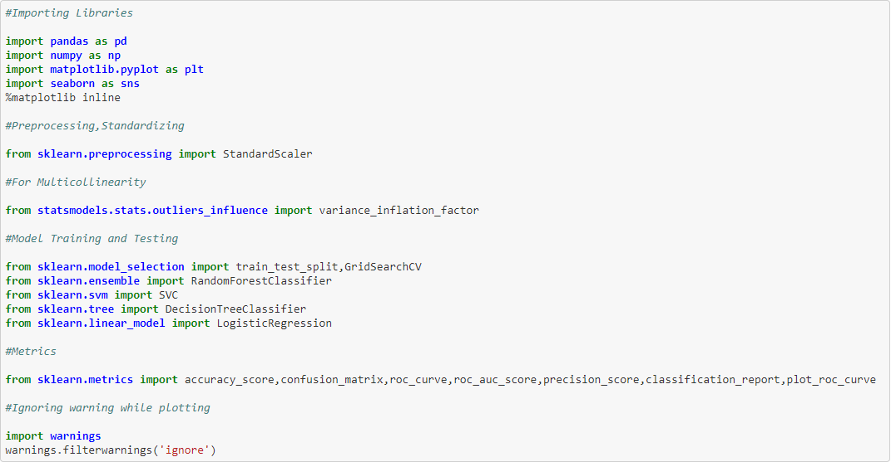
Loading the Data
Data Analysis/Exploratory Data Analysis
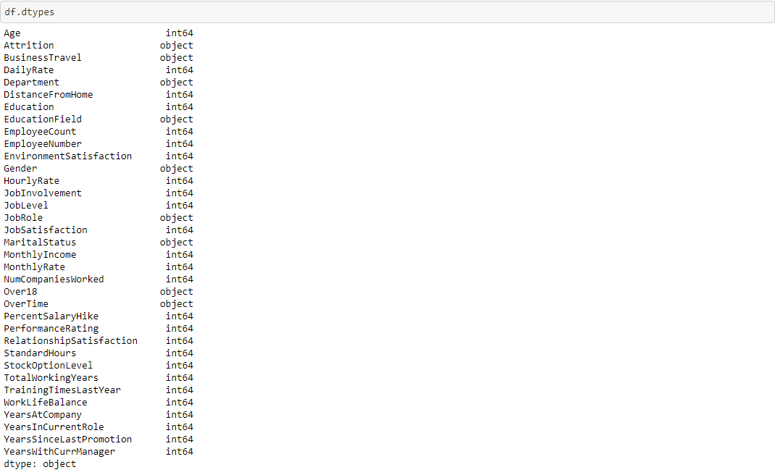
The given dataset contains 1470 observations and 35 variables. 9 of the variables are object i.e string values whereas the rest of the variables are int datatypes. 'Attrition' is our dependent or target variable.
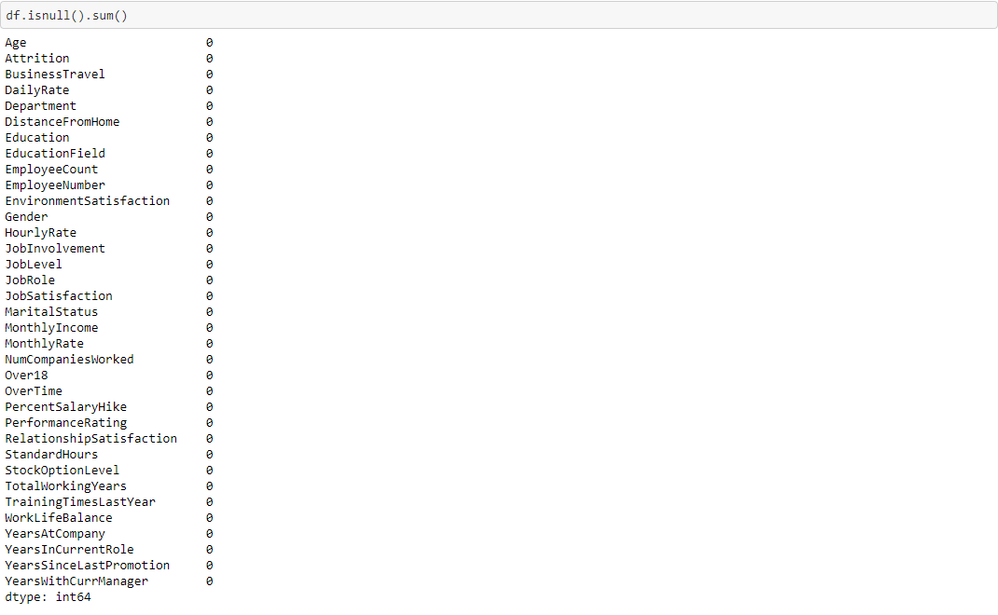
Fortunately, there are no null values, and based on the above HR data snapshot, it appears that we do not need to format the data.
Let's look at the dataset.
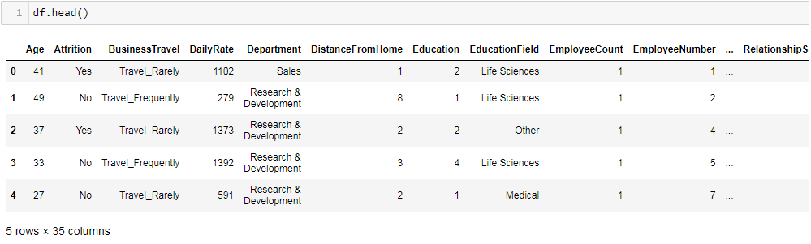
We can learn a few things from the table above. First and foremost, we must transform a large number of features into quantitative ones later on so that machine learning algorithms can interpret them. Furthermore, we can see that the ranges of the features are vastly different, which we will need to adjust to about the same scale. We will do it later. Now, let's proceed to some more insights using data visualization techniques.
Univariate Analysis
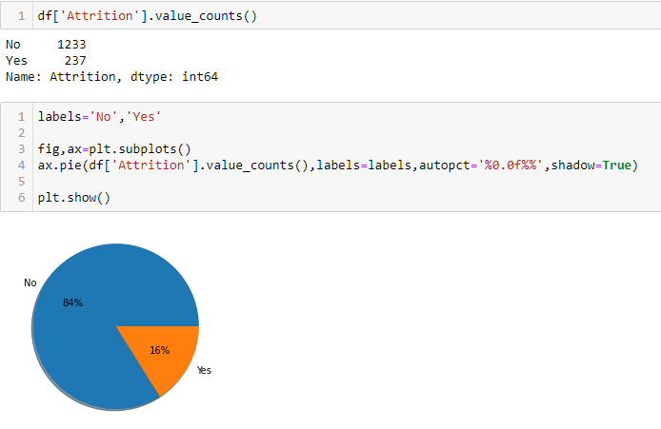
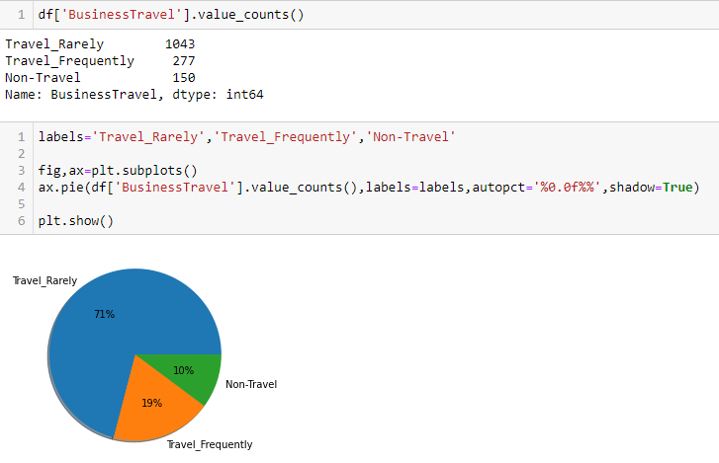
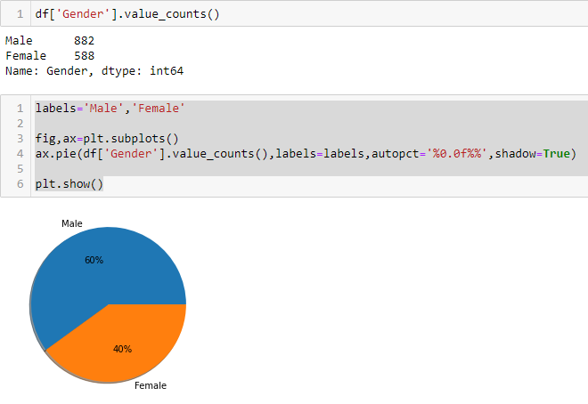
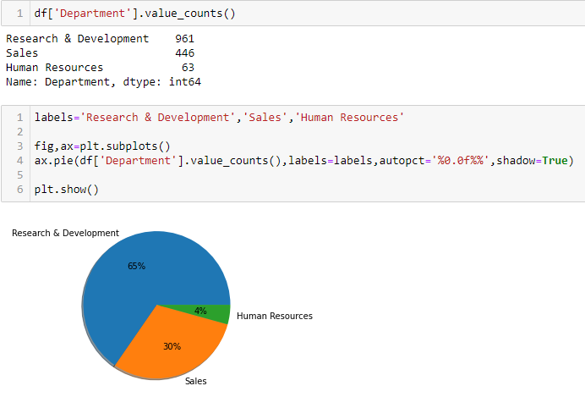
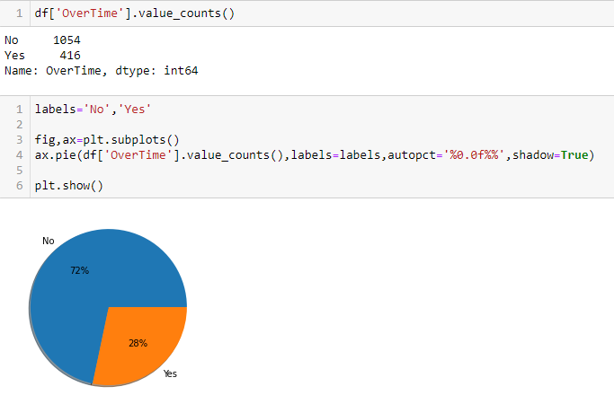
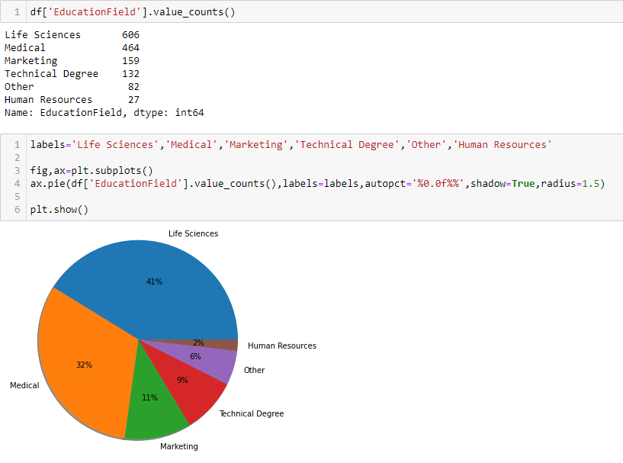

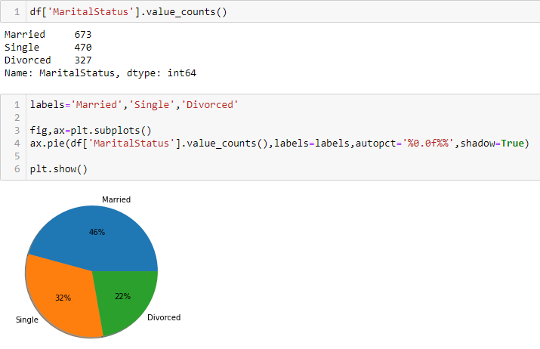
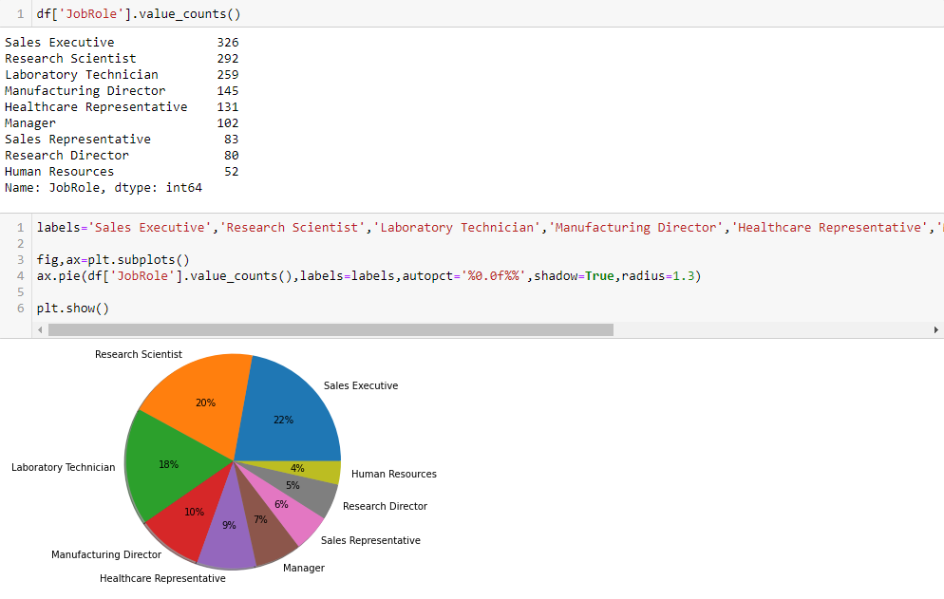
From the above data visualizations, we can conclude that in the given dataset:
- 16% of the people have quit the company while 84% stays in the company.
- 71% who travel rarely, 19% who travel frequently and 10% do not travel at all.
- 65% of the people are from Research & Development Department, 30% from Sales and 4% from Human Resource Department.
- 60% are Male whereas 40% are female.
- 28% do Over Time while 72% do not.
- 46% are Married, 32% are Single and 22% are Divorced.

Bivariate Analysis

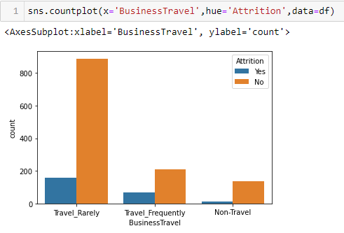
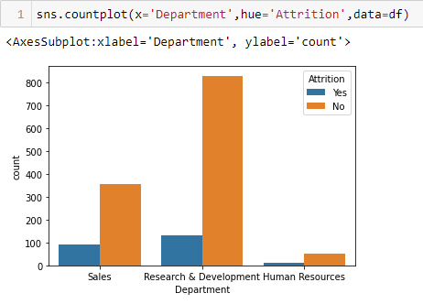
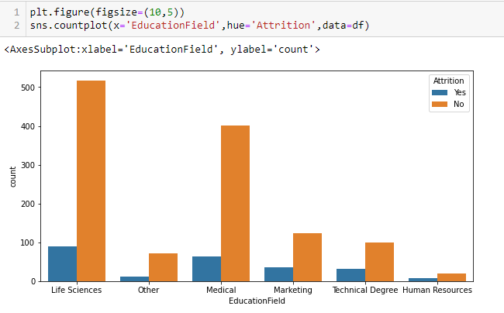
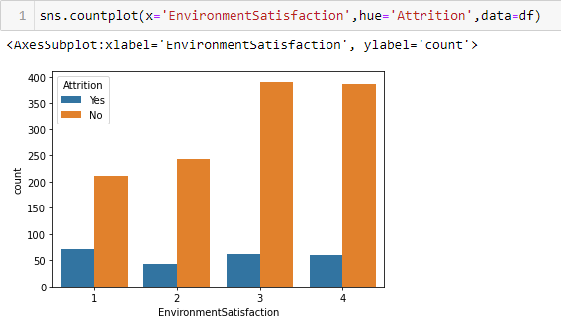
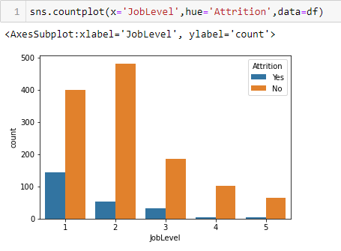
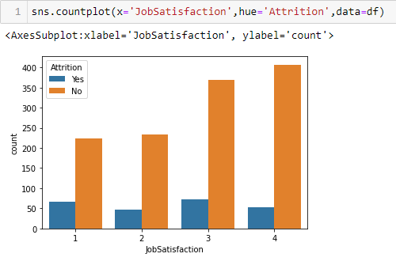
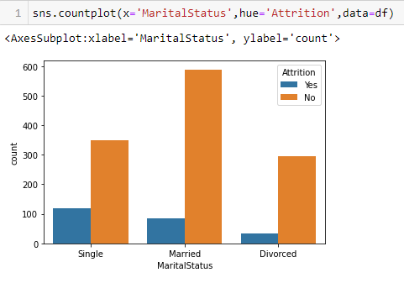
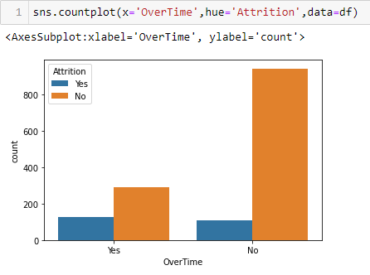
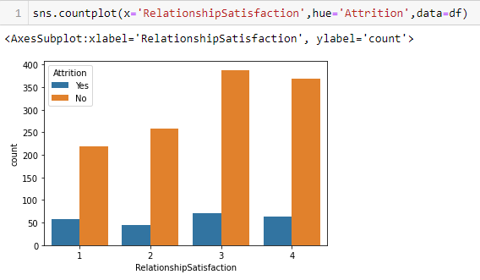
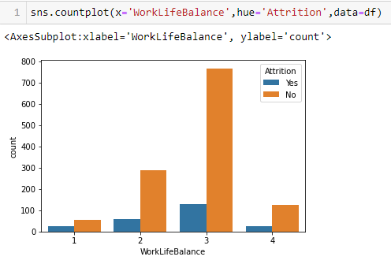
From the above data visualizations we can conclude that:

- People travelling rarely shows the most Attrition while the non travelers shows the least.
- Research & Development Department shows the most Attrition while Human Resource Department shows the least.
- People from Life Sciences field show most Attrition.
- Ones who are not at all satisfied with the environment shows the most Attrition.
- Single people show most Attrition while Divorced shows the least.
- People doing overtime shows most Attrition.
- People with a better work life balance shows the most Attrition.

Multivariate Analysis

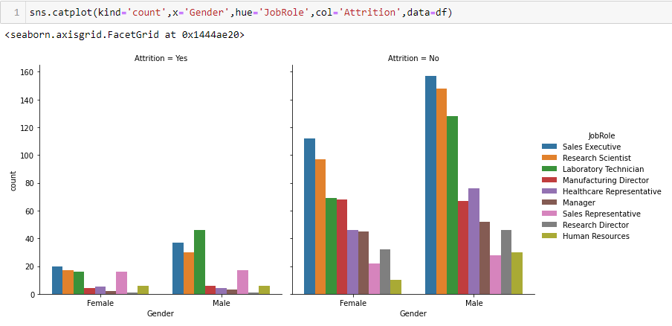
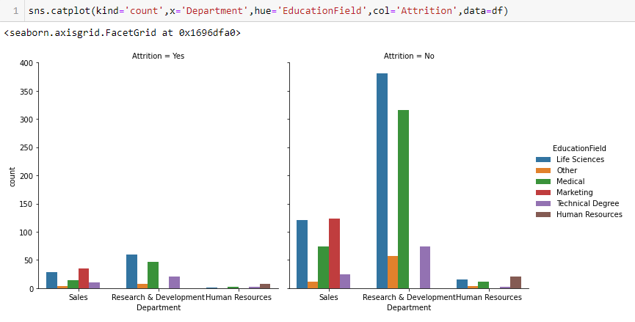
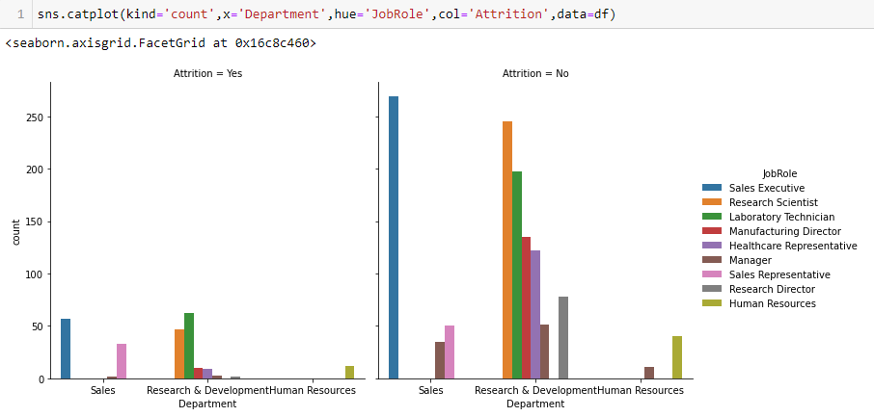
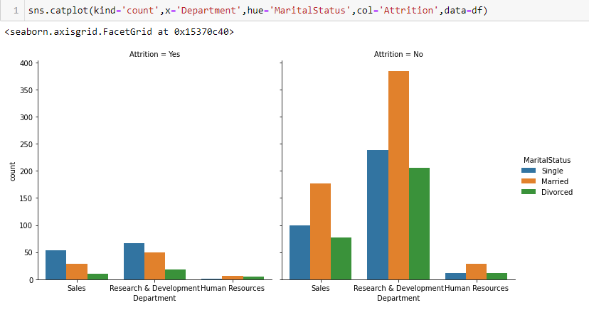

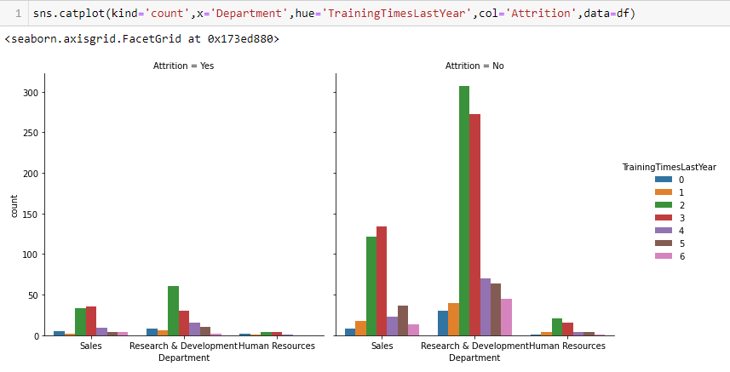
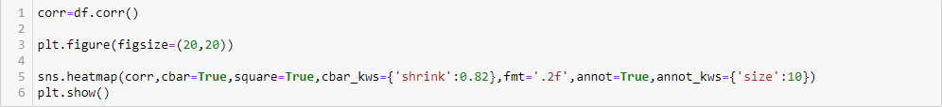
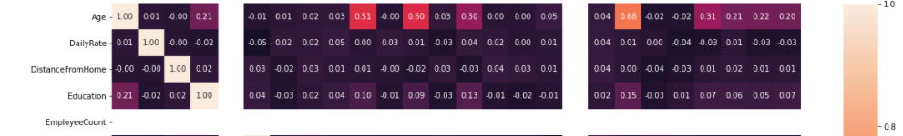
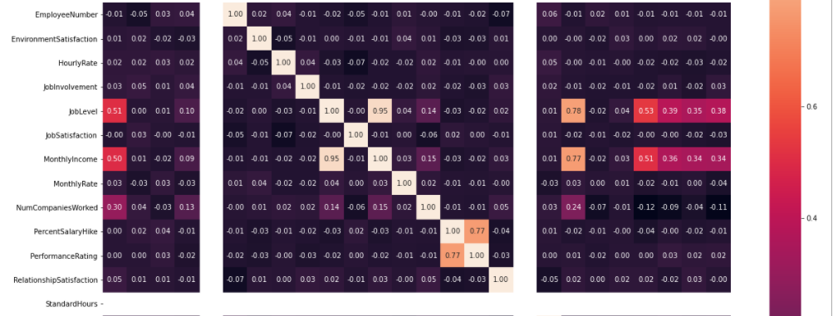
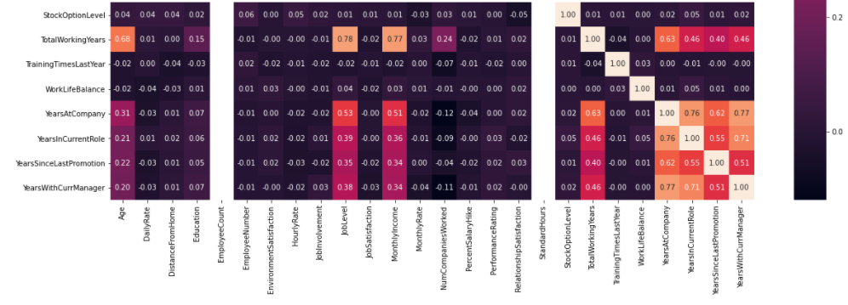
EDA Concluding Remarks
From the above data visualizations of Univariate, Bivariate and Multivariate Analysis, we can conclude that:
- This dataset is not balanced i.e 84% of the people are under the Attrition group No while 16% are under the group Yes.
- Females as a Sales Executive and Males as Laboratory Technician shows high Attrition.
- People with Education Field as Life Sciences show most Attrition in the Research & Development Department while people with Education Field as Marketing show high Attrition in the Sales Department.
- Sales Executive in the Sales Department show high Attrition while Laboratory Technician in the Research & Development Department show most Attrition.
- Single people show high Attrition in the Sales and Research & Development Department while Married people show most Attrition in the Human Resource Department.
- People who took 3 trainings last year show most Attrition in the Sales Department while the ones who took 2 times show high Attrition in the Research & Development Department.
- We see a strong relationship in heatmap between MonthlyIncome & JobLevel, TotalWorkingYears and JobLevel, PerformanceRating & PercentSalaryHike, YearsAtCompany and YearsWithCurrManager.

Pre-processing Pipeline
- Dropping unwanted data
I have dropped EmployeeCount, Over18 and StandardHours columns since it has just one unique value and EmployeeNumber doesn't give meaning to the dataset.
- Dealing with Categorical variables
In machine learning, we typically work with datasets that include numerous labels in one or more columns. Labels might take the shape of words or numbers. The training data is frequently labeled in words to make it comprehensible or human readable.
There are columns in our data that have categorical values. These columns must be processed with either a hot encoding or a label encoder. I have chosen Label Encoder in this project. Label Encoder refers to the process of translating labels into numeric form in order to make them machine readable. Machine learning algorithms can then make better decisions about how those labels should be used. In supervised learning, it is a crucial preprocessing step for the structured dataset.
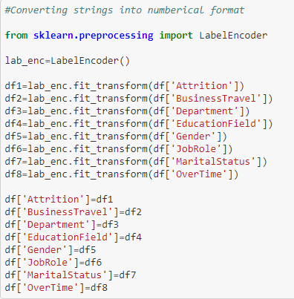
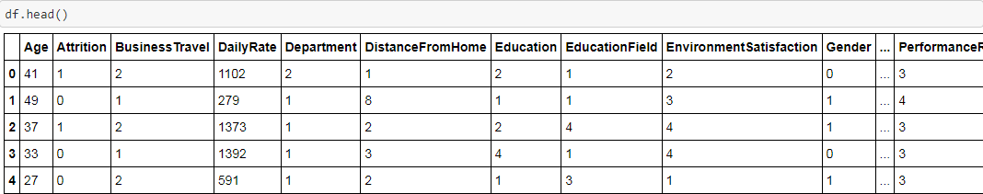
This is how our dataset looks like after encoding.
- Dealing with Outliers
Outliers are data points that are significantly different from other similar ones. They might be caused by measurement variability or by experimental mistakes. Outliers should be eliminated from the data set if at all possible. Detecting that unusual case, on the other hand, may be challenging and not always feasible.
There are various methods to remove outliers such as:
- Z-score
- Interquartile range (IQR)
- Percentile method

However, I have chosen Z-score since IQR method removes huge amount of data which is not feasible. We must always try to keep maximum amount of data. Let's see how we can detect outliers in the first place.
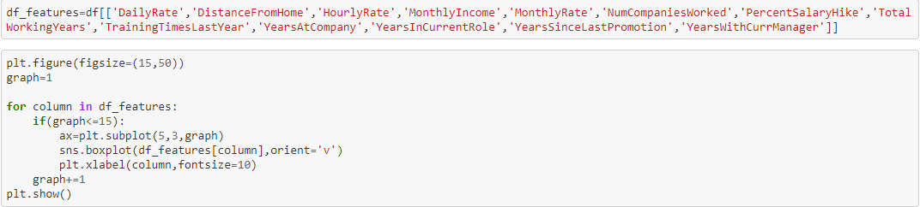
We have to detect outliers only in our numerical variables and not on categorical variables. So, I have chosen all numerical variables from the data and plotted against boxplot.
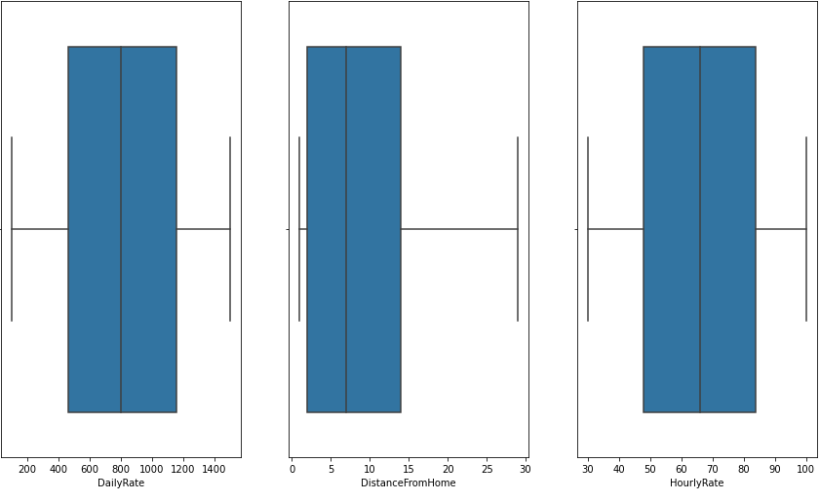
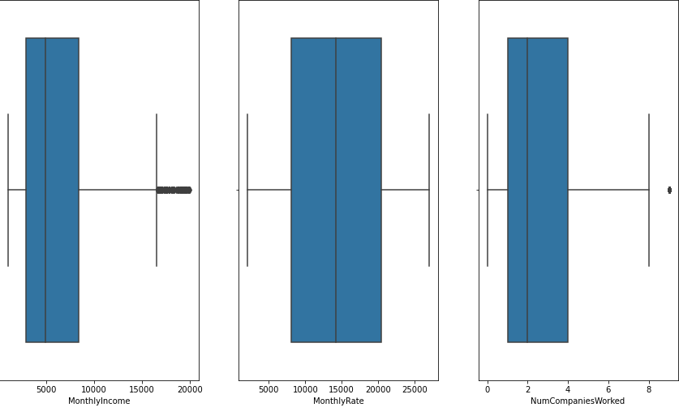
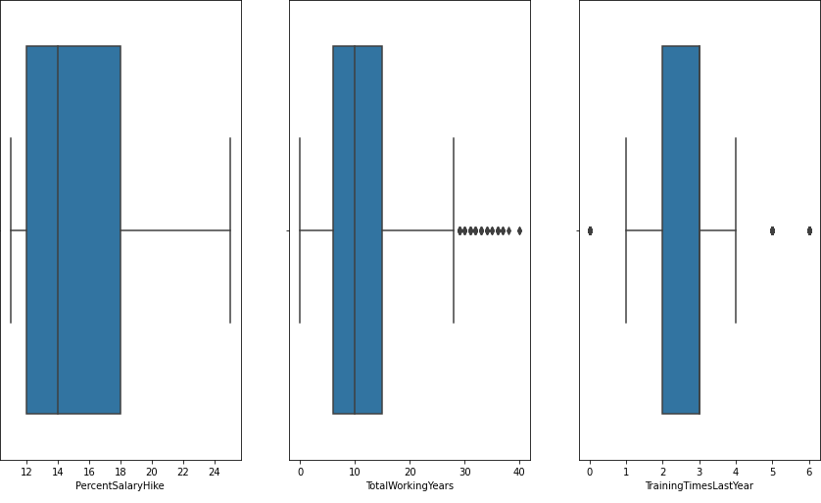
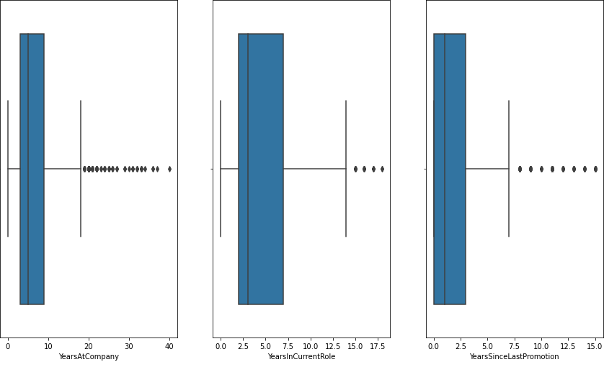
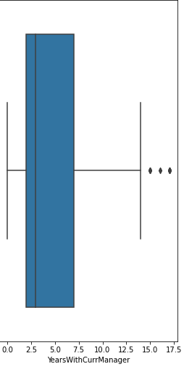
As we can see there are outliers in MonthlyIncome, NumCompaniesWorked, TotalWorkingYears, TrainingTimesLastYear, YearsAtCompany, YearsInCurrentRole, YearsSinceLastPromotion and YearsWithCurrManager.
Now, since we have detected the outliers, let's go ahead and remove them.
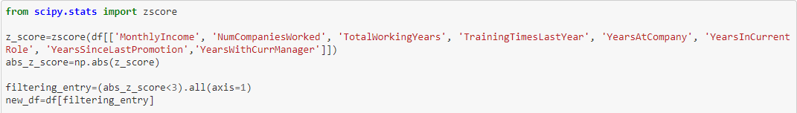
As I said, we don't want to remove huge chunks of data, so let's check how much of data we have lost from the original dataset.
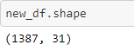
Our original dataset consisted of 1470 rows while our cleaned dataset has 1387 rows. Let's do some basic maths now.
(1470-1387)/1470*100 = 5.64%
So, we have lost around 6% of data which is acceptable, although we always try to keep the percentage under 5.
- Dealing with Skewness
Skewness is the degree of distortion from a normal distribution. Just like outliers, we find skewness only for numerical variables.
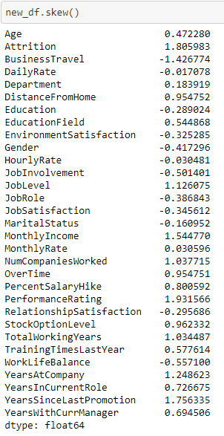
Anything between -0.5 to 0.5 is a normally distributed data and anything beyond that falls under the skewed data. So from the above snapshot, we can see DistanceFromHome, NumCompaniesWorked, MonthlyIncome, PercentSalaryHike, TotalWorkingYears, TrainingTimesLastYear, YearsAtCompany, YearsInCurrentRole, YearsSinceLastPromotion and YearsWithCurrManager are skewed.
There are multiple ways to address skewness such as:
- Square Root Transformation
- Log Transformation
- Reciprocal Transformation
- Power Transformation

Here, I have chosen Square Root method for removing skewness from the data.

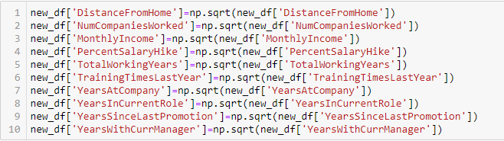
- Balancing our imbalanced data
There are several algorithms available to balance the target variable. To balance our data, I have applied the SMOTE() method. The SMOTE algorithm operates in four simple steps:
- Select a minority class as the input vector.
- Determine its k-nearest neighbors.
- Pick one of these neighbors and draw a synthetic point somewhere along the line connecting the point under consideration and its chosen neighbors.
- Repeat the step until the data is balanced.

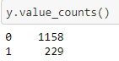
Our data had an initial form of 1153 for Attrition with No value and 229 for Yes. The SMOTE algorithm balances our data with the highest number of values present in it. I will balance my target variable later on during the model training and testing phase.
Building Machine Learning Models
There are numerous models available inside the Sklearn module for building machine learning models. Sklearn offers two kinds of models: regression and classification. The goal of our dataset's target variable is to predict whether or not Attrition is reported. As a result, classification models are used to solve this type of problem.
However, before fitting our dataset to its model, we must first separate the predictor and target variables, and then feed this variable to the train_test_split function to generate a random train and test subset.
Train test split is a sklearn model selection function that divides data arrays into training and testing groups. This function eliminates the need to manually split the dataset. Sklearn train test split will create random partitions for the two subsets by default. You can, however, define a random state for the procedure. It returns four results: x_train, x_test, y_train, and y_test. The training and testing predictor variables are stored in x_train and x_test, respectively, whereas the training and testing target variables are stored in y_train and y_test.
After running train_test_split, we must select the models to which we will feed the training variable. We may create as many models as we like in order to evaluate the accuracy of these models and choose the best one.
- Splitting data into independent and target variable
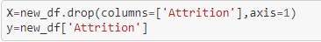
- Balancing our target variable
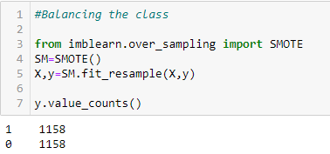
Earlier we have seen our class was not balanced. Now after applying SMOTE() method, we can see the target variable is balanced.
- Standardizing & Multicollinearity check
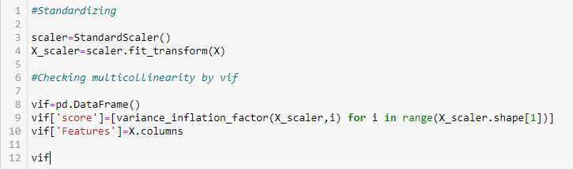
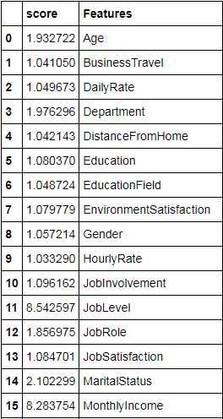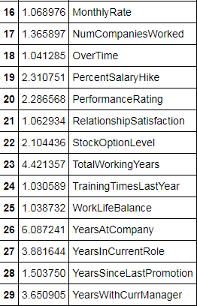
From the above snapshot, we see JobLevel is having high collinearity with MonthlyIncome. So we will drop one of the columns among them, and again scale the data and look for multicollinearity.
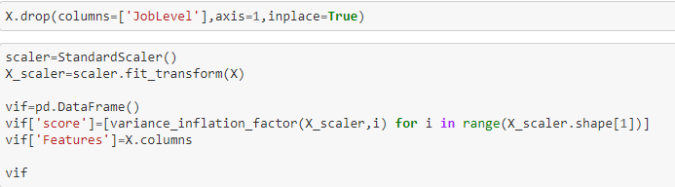
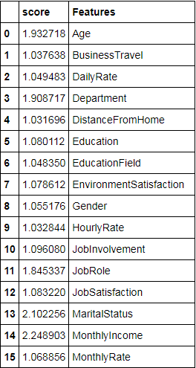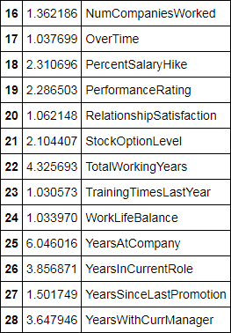
We don't find any collinearity issue among the features. So we move on in finding the best random state for our model.
- Finding the best random state
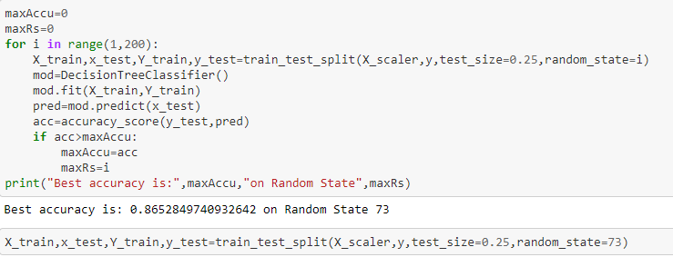
We found our best accuracy for Decison Tree Classifier on random state 73. So using that random state, we have splitted our data into train and test set.
- Finding the best model
As discussed earlier, we can use multiple models to find our best models. I have used 4 models in this project:
- Decision Tree Classifier
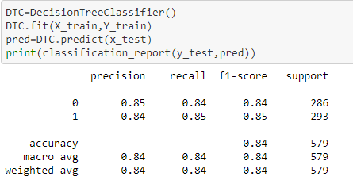
The accuracy for DTC model is 84% and the f1-score is 85%.
- Random Forest Classifier
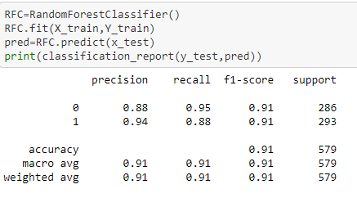
The accuracy and f1-score, both, for RFC model is 91%.
- Support Vector Classifier
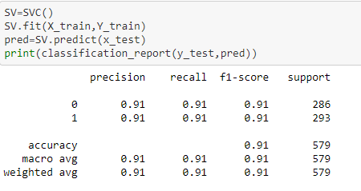
The accuracy and f1-score, both, for SVC model is 91%.
- Logistic Regression
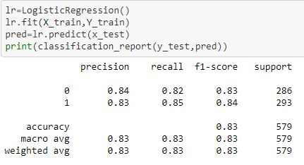
The accuracy for Logistic Regression is 83% while f1-score is 84%.
- Cross Validation
Cross-validation is a statistical approach for estimating the performance (or accuracy) of machine learning models. Here, we will find out the cross validation for each of these models mentioned above and based on the least difference between the accuracy and the cross validation, we will pick our best model.
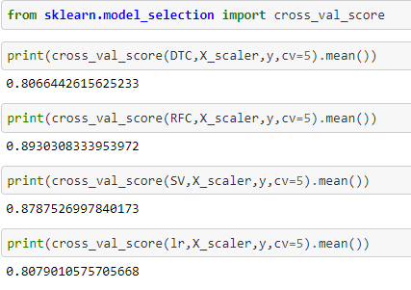
- Confusion Matrix
A Confusion matrix is a N x N matrix that is used to assess the effectiveness of a classification model, where N is the number of target classes. The matrix compares the actual target values to the machine learning model's predictions. This provides us with a comprehensive picture of how well our classification model is working and the kind of errors it is producing.
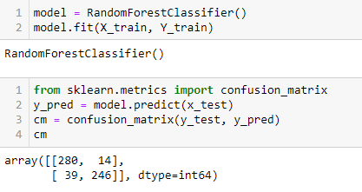
Conclusion from models
From the above snapshots, we find the least difference between accuracy and cross validation is in Random Forest Classifier. Therefore, we got our best model i.e. Random Forest Classifier with the accuracy score of 91%.
Our model predicts 280 true positive cases out of 294 positive cases and 246 true negative cases out of 285 cases. It predicts 14 false positive cases out of 294 positive cases and 39 false negative cases out of 285 cases. It gives the f1 score of 91%. By doing basic maths again, (14+39)/(294+285)*100 = 9.1%. So our model mispredicts 9% of our data.
Hyper parameter Tuning
In machine learning, hyper parameter optimization seeks to identify the hyper parameters of a particular machine learning algorithm that provide the best performance as evaluated on a validation set. Basically, it just means to improve our accuracy.
There are various methods for hyper parameter tuning such as:
- Grid SearchCV
- Random SearchCV
- Bayesian Search
- Evolution Search

I have used Grid SearchCV for the hyper parameter tuning. In the Grid SearchCV method, the machine learning model is assessed for a variety of hyper parameter values. This method is called Grid SearchCV because it seeks the optimal set of hyper parameters from a grid of hyper parameter values. I have tuned using the parameters n_estimators, max_features, criterion and max_depth.
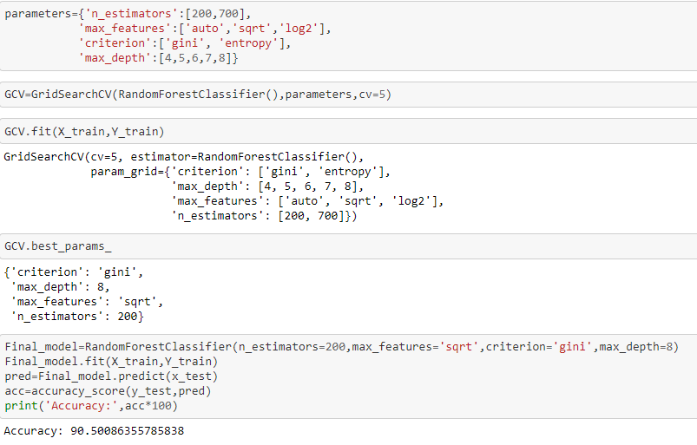
As seen, we got our best parameters in criterion - gini, max_depth - 8, max_features - sqrt and n_estimators - 200 and by using these we have got an accuracy of 90.5% which is nearly the same as 91% for RFC model.
Plotting ROC curve
The ROC curve is a performance indicator for classification problems with varying threshold values. AUC is the degree or measure of separability, whereas ROC is a probability curve. It indicates how well the model can differentiate between classes. The greater the AUC, the better the model predicts 0s as 0s and 1s as 1s.
The ROC curve is shown using TPR vs FPR, with TPR on the y-axis and FPR on the x-axis.
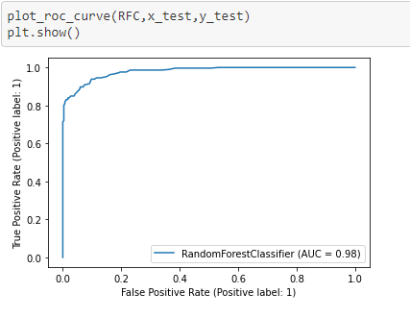
Concluding Remarks
This project has developed a model for detecting employee attrition. As a result, the approach can help businesses decrease losses.
In this project, 4 different classifiers were used: Decision Tree, Random Forest, Support Vector and Logistic Regression. The imbalanced class were handled by using oversampling with SMOTE, and various other techniques were used such as hyper parameter tuning and plotting roc curve of the best model.
The Random Forest model with an F1 score of 0.91 and a ROC AUC of 0.98 was the best and final fitted model. The model performed wonderfully. The model has the greatest F1 and ROC AUC values among the other models. Finally, the model was able to distinguish between 0s and 1s of Attrition. Most importantly, we discovered characteristics that are most essential to employees and, if not met, may result in attrition.

